Sharekatcom application

*team:*

|  |  |
| --- | --- |
| Sami Abdul Kareem Alsanabrah | 202010437 |
| Ahmed Jamal Karzoun | 201910082 |
| Anas Ibrahim aljawabrah | 202130057 |

Team leader: Ahmed Jamal Karzoun

Tools and Technologies Used:

1.Flutter

2. Firebase

3. Android Studio

4. GitHub

Cover Page

Software Design Document (SDD)

Sharekatcom application

Version: 3.0.0

13/8/2023

link GitHub: <https://github.com/ahmadkarazou/Sharekatcom>

Amane Arabah University

Revisions Page

|  |  |  |  |
| --- | --- | --- | --- |
| Version | Primary Author | Description of Version | Date Completed |
| 3.0.0 | Ahmad Karzoun | Ahmad Karzoun | 13/8/2023 |

1. System Design
   1. System Interfaces
   2. User Interface
   3. System Design
      1. Activity Diagram
      2. Use Case Diagram
      3. Class Diagram
      4. Sequence Diagram
      5. ER-Diagram
2. System Design

System Design is the core concept behind the design of any distributed system. System Design is defined as a process of creating an architecture for different components, interfaces, and modules of the system and providing corresponding data helpful in implementing such elements in systems.

1.1 System Interfaces

The Sharekatcom app platform will require several system interfaces to enable communication and data exchange between the different components of the system. Here are some of the system interfaces that may be included in the design of the Sharekatcom app platform:

1.2 User Interfaces

The user interface is the primary interface for users to interact with the Sharekatcom app platform. designed to be user-friendly and intuitive, with a focus on ease of use and accessibility. The user interface may include features such as search functionality. Figs. 3, 4, 5, 6, 7, 8, and 9.

صورة تحتوي على نص, لقطة شاشة, الخط, مستطيل

تم إنشاء الوصف تلقائياًصورة تحتوي على نص, لقطة شاشة, الخط, التصميم

تم إنشاء الوصف تلقائياً

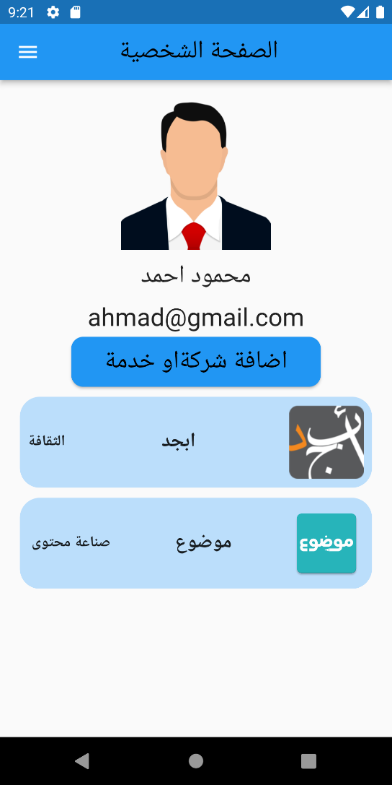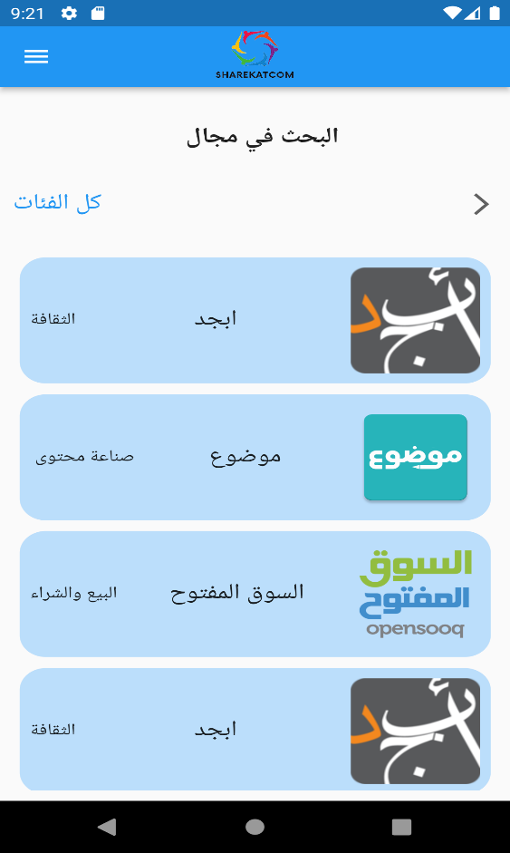 Figure 3: sign in Figure 4: Choose an account

Figure 5: Home page Figure 6: personal page

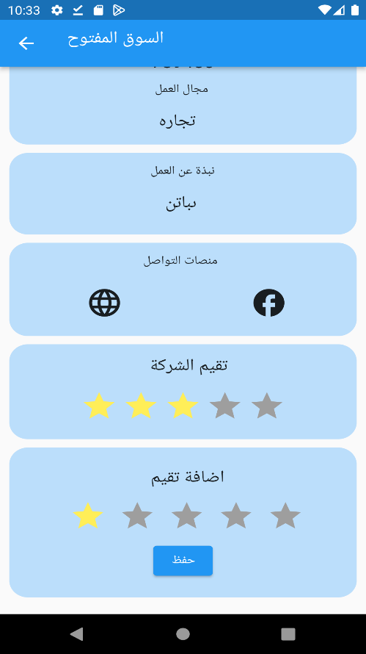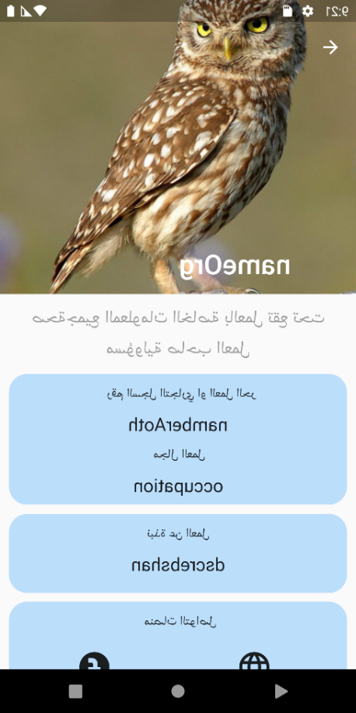

Figure 7: Company page Figure 8: Rate page

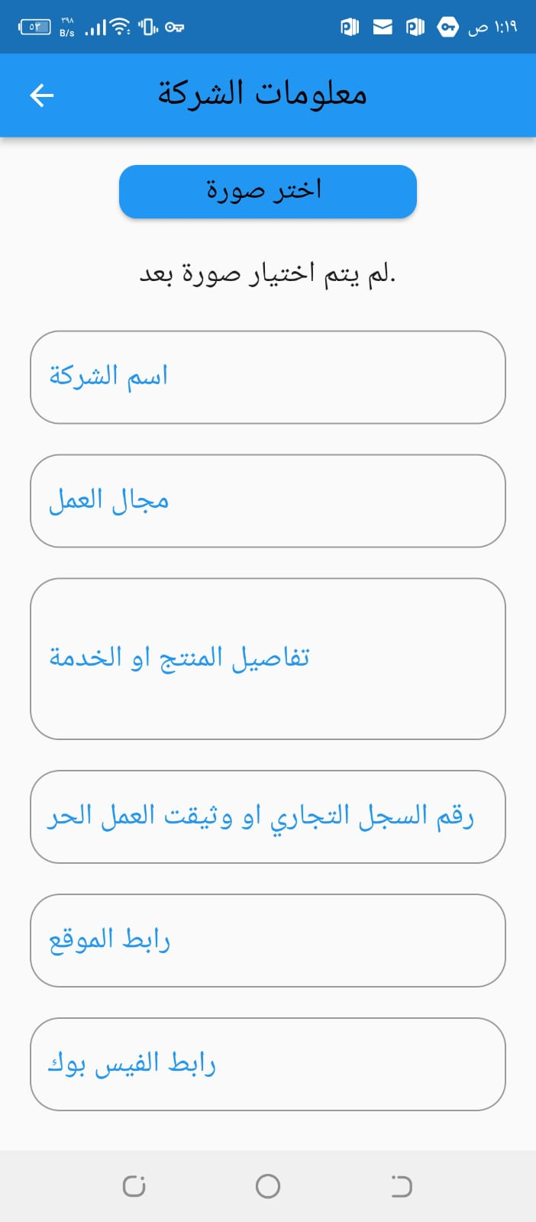Figure 9: company information

* 1. System Design

System Design is the core concept behind the design of any distributed system. System Design is defined as a process of creating an architecture for different components, interfaces, and modules of the system and providing corresponding data helpful in implementing such elements in systems.

1.3.1 Activity Diagram

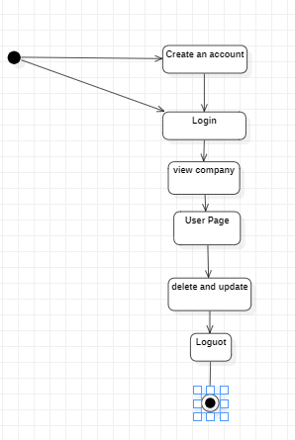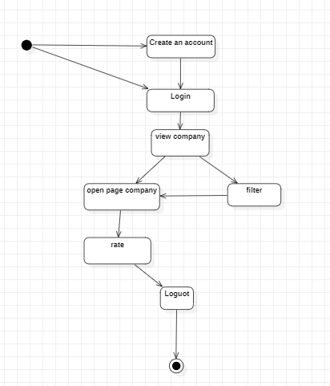An activity diagram that illustrates the flow of activities in a system or process. It is used to model the steps in a process, such as a business process or software workflow, and to show the interactions between different elements of the process. fig. 10 show the Activity Diagram

Figure 10: Activity Diagram

* + 1. Use Case Diagram

A use case diagram that represents the behavior of a system from a user's perspective. the system, and the specific use cases that the system performs in response to those interactions. fig. 11 show the Use Case Diagram.

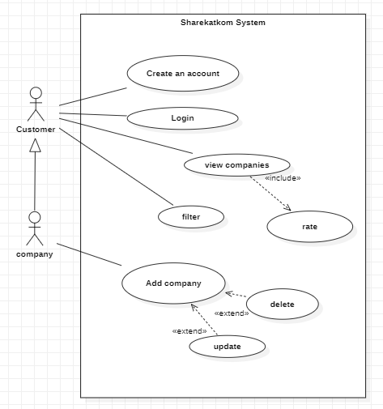

Figure 11­­: Use Case Diagram

* + 1. Class Diagram

A class diagram that represents the static structure of a system by showing its classes, their attributes, methods, and relationships. It is used to model object-oriented software systems. fig. 12 show the Class Diagram.

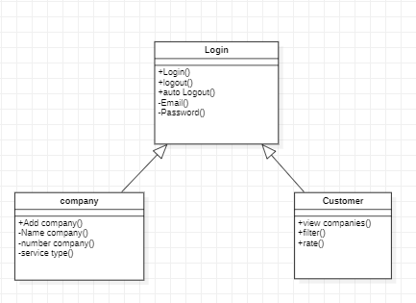

Figure 12:Class Diagram

* + 1. Sequence Diagram

A sequence diagram that shows the interactions between objects or components in a system over time. It is used to model the dynamic behavior of a system and to visualize how the system responds to a particular scenario or use case. [3] fig. 13 show the Sequence Diagram.

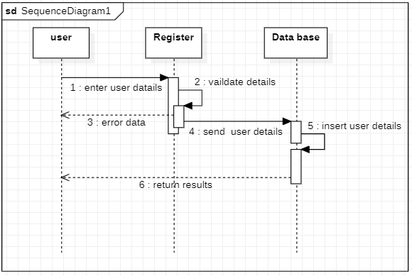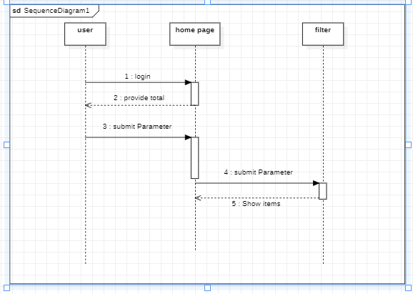 Figure 13: Sequence Diagram

1.3..5 ER Diagram

ER diagram that represents the relationships between entities in a system. It is used to model the data requirements of a system and to visualize the relationships between different entities. [4] fig. 14 show the ER Diagram.

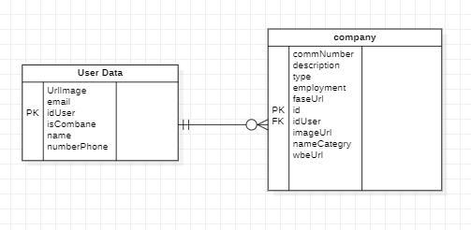

Figure 14: ER Diagram